**Hochschule Flensburg Wind Energy Technology Institude**

University of Applied Science Research on wind Energy

**Advance Wind Farm Development, WiSe 2024/25**

Master’s degree in Wind Engineering, Flensburg, Germany

**Submitted by**

Karan Soni (760153)

Mozafary Mostafa (750247)

Patil Rahul (750532)

**Supervising Professors:**

Prof. Dipl.-Met. Eva Maria Nikolai

Prof. Dr. Jörg Winterfeldt

**Exam Date:** 16.01.2025

**Date of submission:** 05.02.2025

Table of Contents

1. Introduction and Motivation 2

2. Methodology 4

3. Wind Farm Development 6

3.1 Baseline layout without flicker and noise requirements 8

3.1.1 Layouts of Vestas V150-4.5MW HH125 9

3.1.2 Comparison of different Layout of Vestas V150-4.5MW HH125 10

3.1.3 Layout of Enercon E-147 EP5 E2 5000 HH 127 11

3.2 Flicker and Noice considering for Wind Farm Layout 12

4. Results 12

5. Recommendations for Future Work 12

6. Conclusion 12

7. References 12

8. Appendix 12

# Introduction and Motivation

This report presents general information on wind farm planning area. The project was developed as part of the exam “Advance Wind Farm Planning” module within the Wind Energy Engineering Master’s Program at the University of Applied Sciences in Flensburg. Wind farm planning is increasing energy production and energy quality as well as reduce structural load. [1]

The shapefile already provided into exam, which shows the planned wind farm area, including all exclusion zones, so no need to consider distances to roads or boundaries. The tip height is limited to **200 meters**. Lidar measurements were taken at coordinates **548207 E, 6061864 N (UTM ETRS89 Z32).** This report presents wind farm layouts for **Vestas V150-4.5MW** and **Enercon E-147 EP5 E2 5000** turbines, considering maximum hub height limit. The layouts follow a minimum spacing of **5 RD** in the main wind direction and **3.5 RD** perpendicular.

The Objective of this report is to estimate the energy yield for the baseline layout of two turbines, considering losses, without accounting for flicker and noise. The calculations will include the Levelized Cost of Energy (LCOE), Net Present Value (NPV), and Internal Rate of Return (IRR) for each turbine layout. The same calculations will be repeated, this time including flicker, noise, and bat losses. Based on the NPV, the report will identify the best compliant layout. Finally, the **P75** and **P90** Annual Energy Production (AEP) will be calculated for the selected best compliant layout.

Chapter 2 discusses the method used to achieve the objective. Chapter 3 covers our wind farm layout with two types of wind turbines, both with and without requirements. Chapter 4 investigate into the optimization process we followed during the exam time **(4 hours)**. Chapter 5 presents the results of the report. Chapter 6 discusses how the optimization of the wind farm could be improved if more time was available during the exam.

For the achieved of these tasks, we used lecture notes and the WindPro software, which we learned during class.

# Methodology

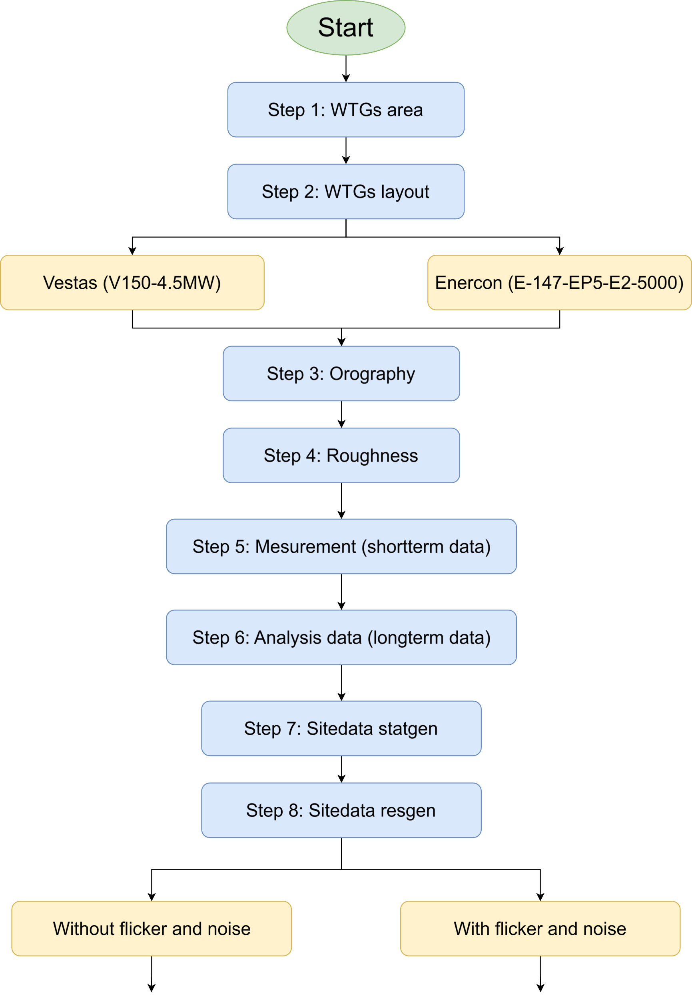

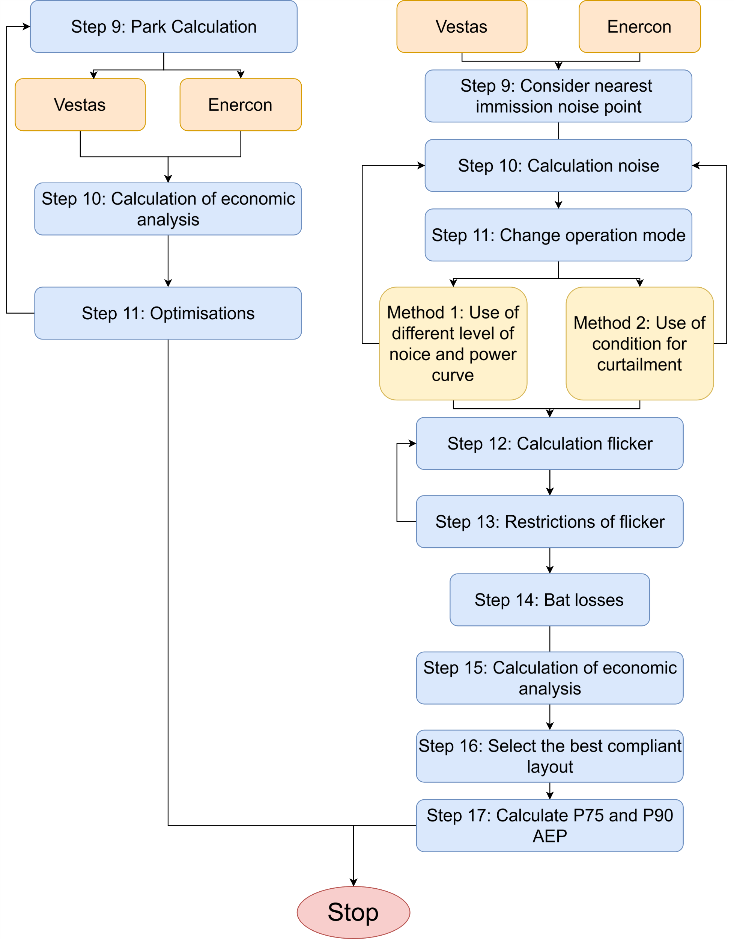

# Wind Farm Development

The wind area was already provided in the exam, so we did not create it (see figure 3.1).

Figure 3. : WTGs area

In our calculations, we considered both orography and roughness, as they are crucial factors. Orography refers to the shape of the terrain, such as mountains and valleys, as well as elevation, which impact wind speed and direction. Roughness relates to the surface texture, including forests, buildings, and water bodies, which affect the wind profile near the ground. These factors play a significant role in accurately assessing wind conditions [2].

Figure 3. : Orography

Figure 3. : Roughness

The short-term LiDAR data was already provided in the exam, so we imported it into WindPro for further analysis. The long-term wind data was sourced online and also imported into WindPro, which is ERA5(T) (See figure 3.4).

Figure 3. : Long term data ERA5(T)

To process and analyze the data, we used SiteData STRAGEN to generate site-specific wind statistics and SiteData RESGEN to create resource grids based on the available data. These steps allowed us to evaluate the wind resource distribution across the study area.

Figure 3. : Long term and short term data comparisons

After processing the data, we performed a comparative analysis using MCP (Measure-Correlate-Predict). This method helped in correlating the short-term LiDAR data with the long-term dataset, ensuring accurate long-term wind predictions. The MCP process enhances the reliability of wind resource assessments by adjusting for variations and filling gaps in the data, ultimately improving the accuracy of energy yield estimations. We applied four different models for comparison, but the neural network model showed the closest resemblance to the long-term data (see figure 3.5). Therefore, we selected this model as the most reliable for our analysis.(see figure 3.6)

Figure 3. MCP output

## Baseline layout without flicker and noise requirements

Before placing the wind turbines, we considered the wind direction, which is crucial for minimizing wake effects and optimizing energy production. This approach helps increase the Annual Energy Production (AEP) and enhances the overall profitability of the project by ensuring an efficient wind farm layout. As shown in Figure 3.7, the wind rose illustrates the predominant wind directions, and we specifically considered a **240-degree** wind direction for our analysis.

Figure 3. : Wind rose

For the wind turbine layout, we considered both wake direction and wake distance to minimize energy losses and optimize efficiency. The wake direction was analyzed using an elliptical shape, where the major direction was set to **5R** and the minor direction to **3.5R** ( see Figure 3.8). This approach ensures better spacing between turbines, reducing wake effects and improving overall energy output.

Figure 3. : Distance circle for wind turbine

### 3.1.1 Layouts of Vestas V150-4.5MW HH125

As shown in Figure 3.9, the wind turbine layout features Vestas V150-4.5MW HH125 turbines. In our initial approach, we designed the wind farm layout with a total of six turbines, carefully considering wind direction and wake effects to maximize efficiency.

Figure 3. : Six wind turbine of Vestas V150 – 4.5MW HH125

As shown in Figure 3.10, the wind turbine layout features Vestas V150-4.5MW HH125 turbines. In our second approach, we designed the wind farm layout with a total of five turbines, carefully considering wind direction and wake effects to maximize efficiency. The wind turbine layout features Vestas V150-4.5MW HH125 turbines. In our third approach, we designed the wind farm layout with a total of seven turbines.

Figure 3. : Five wind turbine of Vestas V150 – 4.5MW HH 125

### 3.1.2 Comparison of different Layout of Vestas V150-4.5MW HH125

The AEP for the wind farm layout with five Vestas V150-4.5MW HH125 turbines is **82,810 MWh/year**, considering **4%** wake losses (see Figure 3.11). The calculated Net Present Value (NPV) is **[...]**, and the Internal Rate of Return (IRR) is **[...]**.

Figure 3. : Wind park result for five Vestas wind turbines

The AEP for the wind farm layout with six Vestas V150-4.5MW HH 125 turbines is **98,137.1 MWh/year**, considering **5.1%** wake losses (see Figure 3.12). The calculated Net Present Value (NPV) is **[...]**, and the Internal Rate of Return (IRR) is **[...]**.

Figure 3. : Wind park result for six Vestas wind turbines

The AEP for the wind farm layout with six Vestas V150-4.5MW HH 125 turbines is **112,331.2 MWh/year**, considering **6.8%** wake losses (see Figure 3.13). The calculated Net Present Value (NPV) is **[...]**, and the Internal Rate of Return (IRR) is **[...]**.

Figure 3. : Wind park result for seven Vestas wind turbines

We selected the layout with six wind turbines for the wind farm park because it provided the best NPV and IRR compared to the layouts with five or seven turbines. This configuration offered the most favorable financial performance for the project.

### 3.1.3 Layout of Enercon E-147 EP5 E2 5000 HH 127

As shown in Figure 3.14, the wind turbine layout features Enercon E-147 EP5 E2 5000 HH 127 turbines. However, as discussed in the previous chapter, the layout with six wind turbines proved to be the most optimal for maximizing both the NPV and Internal Rate of Return IRR of the project.

Figure 3. : Six wind turbine of Enercon E147 EP5 E2 5000 HH 127

## Noise and Flicker considering for Wind Farm Layout

### 3.2.1 Noise

Figure 3. : Residencial and other area near to wind farm area

# Results

# Recommendations for Future Work

# Conclusion

# References

# Appendix